PROJECT WORK

AUGMENTED REALITY
A Project Report Submitted
for
INFORMATION TECHNOLOGY
By
Mansi Joshi
(Roll No.22)
Under the Guidance of
Mr. Praveen Kumar Joshi


EVER GREEN SENIOR SECONDARY SCHOOL
(GOVERNED BY EDUCATIONAL WELFARE SOCIETY)
TULARAMPUR – 263139, DISTRICT – NAINITAL
UTTARAKHAND, INDIA

OCTOBAR, 2021

CERTIFICATE

This is to certify that the project entitled “AUGMENTED REALITY” being submitted to
Evergreen Senior Secondary School, Haldwani for the project work of INFORMATION
TECHNOLOGY is a record of the work carried by MR. PRAVEEN KUMAR JOSHI under
my guidance and supervision.

Date: 9/10/2021 Supervisor
Supervisior MR. PRAVEEN JOSHI
TGT Computer
Ever Green Sr. Sec. School
Halwani
Forwarded By:
MR. M.S. Parwal
Principal
Ever Green Sr. Sec. School Halwani

ACNOWLEDGEMENT
I would like to express my most sincere heartfelt gratitude and respect to my supervisor MR.
PRAVEEN JOSHI sir for suggesting the topic for my project work and for his excellent guidance, valuable suggestions and endless support throughout the course of my preparing the report. I am greatly indebted to him for his constructive suggestions and criticism from time to time during the course of progress of my work.
I would like to express my guidance and sincere thanks to Mr. M.S. Parwal, Principal of school, and entire faculty who has imparted considerable knowledge to me.
I am also thankful to all my friends and the staff members of the department Computer Science & Engineering and to all my well-wishers for their inspiration and help. And thanks for the information given to me by GOOGLE and YOUTUBE.
Finally, I express my deepest gratitude to my parents for their continuous encouragement, understanding and support.
(MANSI JOSHI)

ABSTRACT
My project is based on topic Augmented Reality. Augmented Reality is one of the biggest
technology trends right now. It is a technology that superimposes a computer- generated
image on a user’s view of the real world, thus providing a composite view.
Augmented Reality (AR) is an enhanced version of the real physical world that is achieved
through the use of digital visual elements, sound, or other sensory stimuli delivered via
technology. It is a growing trend among companies involved in mobile computing and
business applications in particular.
It is an interactive experience of real world environment where the objects that reside in the
real are enhanced by computer-generated perceptual information, sometimes across multiple
sensory modalities. AR let you see the real life environment right in front of us.

TABLE OF CONTENTS
CHAPTER | TOPIC | PAGE NO.
 | CERTIFICATE | 2
 | ACKNOWLEDGEMENT | 3
 | ABSTRACT | 4
 | INTRODUCTION | 6
1 | CREATOR | 7
2 | WHAT IS AR USED FOR? | 7
3 | WHAT IS POSSIBLE WITH AR | 7-8
3.1 | 10 Intriguing uses of AR technology in industry | 7
4 | SOME EXAMPLES OF AR BRAND EXPERIENCES | 8
5 | HOW IT WORKS | 9-10
6 | ADVANTAGES AND DISADVANTAGESS OF AUGMENTED REALITY | 10-11
6.1 | Advantages | 10
6.2 | Disadvantages | 10-11
7 | FUTURE OF AUGMENTED REALITY | 11
8 | SUMMARY | 11

LIST OF FIGURES
S. No | Name | Page No.
1 | Augmented Reality Image | 6
2 | Smart Augmented Reality | 7
3 | Augmented Reality in Education | 8
4 | How AR is used | 10

INTRODUCTION
The world is advancing more and more than before. New technologies are coming up day by day and they are affecting our lives very much. So a new technology Augmented Reality is here and its details are below:
Augmented Reality (AR) is one of the bigger technology trends right now, and its only going to get bigger as AR ready smartphones and other devices become more accessible around the world.
Augmented Reality (AR) is an interactive experience of real-world environment where the objects the reside in the real world are enhanced by computer-generated perceptual information, sometimes across multiple sensory modalities, including visual, auditory, haptic, somatosensory and olfactory. AR let you see the real-life environment right in front of us.
AR can be defined as a system that incorporates three basic features:
- A combination of real and virtual worlds.
- Real time interaction
- And accurate 3D, registration of virtual and real objects.
Augmented Reality is, in fact, readily available and being used in a myrid of ways including as snapchat lenses, and in other app also.
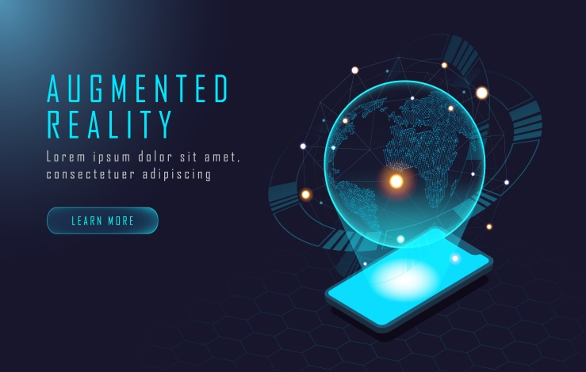
This experience is seamlessly interwoven with the physical world such that it is perceived as an immersive aspect of real environment. In this way, augmented reality alters one’s ongoing perception of a real-world environment.

Fig-1.1 Augmented Reality image
CREATOR
Augmented Reality was first discovered, to some extent, by a cinematographer called MORTON HELLIG in 1957. He invented the Sensorama which delivered visuals, sounds, vibrations and smell to the viewer.
The first properly functioning AR system was probably the one developed at USAF Armstrong’s Research Lab by Louis Rosenberg in 1992. This was called Virtual Fixtures and was an designed to compensate for the lack of high-speed 3D graphics processing power in the early90s. It enabled the overlay of sensory information on a workspace to improve human productivity
WHAT IS AUGMENTED REALITY USED FOR?
Augmented Reality (AR) involves overlaying, visual, auditory or other sensory information onto the world in order to enhance one’s experience. Retailers and other companies can use augmented reality to promote products or services, launch novel, marketing campaigns, and collect unique user data.


Fig-1.2 Smart Augmented Reality
WHAT IS POSSIBLE WITH AR?
Augmented Reality is now used in medical training. Its applications range from MRI applications to performing highly delicate surgery. At the Cleveland Clinic at Care Western Reserve University.
For example- Students are taught the ins and outs of anatomy using Augmented Reality (AR) headsets or augmented reality glasses.
10 Intriguing Uses of AR Technology in Industry-
- Enhanced Surgical Training And Performance
- Property Tours and Real Estate Models
- Immersive Therapy
- Apprentice Training in Skilled Trades
- Heavy Machinery Training
- Specialized Auto Maintenance
- Oil and Gas Industry Training
- Retail / Hospitality Training
- Military Training and Readiness
- Edutainment
Some examples of augmented reality brand experiences
- Walmart – testing AR for inventory
- Snap – City Painter
- ASOS – See My Fit
- Pull and Bear – Video Game
- Burberry – Olympia Pop Up at Harrods
- IKEA Studio app
- Amazon – hair coloring at Amazon Salon
- Gucci – virtual sneakers
- Wayfair – View in Room
- Machine A – virtual concept store
- Sephora – virtual artist
- Kohl’s – virtual closet with Snapchat
- Modiface on Amazon
- Adidas – more virtual speakers


Fig-1.4 Augmented Reality in education.

HOW IT WORKS
It starts with a camera-equipped device such as smartphones, a tablet, or smart glasses – loaded with AR software. When a user points the device and looks at an object the software recognizes it through computer vision technology, which analyzes the video stream.
The device then downloads information about the object from the cloud, in much the same way that a web browser loads a page via a URL. A fundamental difference is that the AR information is presented in a 3-D “experience” superimposed on the object rather than in a 2-D page on a screen. What the user sees then is part real and part digital.
AR can provide a view of the real-time data flowing from products and allow users to control them by touchscreen, voice or gesture.
As the user moves, the size and orientation of the AR display automatically adjust to the shifting context. New graphical or text information comes into view while other information passes out of view. In industrial settings, users in different roles, such as a machine operator and a maintenance technician, can look at the same object but be presented with different AR experience that are tailored to their needs.
A 3-D digital model that resides in the cloud-the object’s “digital twin”-serves as the bridge between the smart object and the AR. This model is created either by using computer-aided design, usually during product development, or by using technology that digitizes physical objects. The twin then collect information from the product, business systems, and external sources to reflect the product’s current reality. It is the vehicle through which the AR software accurately places and scales up-to-date information on the object. The primary value of augmented reality is the manner in which components of the digital world blend into a person’s perception of the real world, but not as a simple display of data, but through the integration of immersive sensations, which are perceived as natural parts of an environment. The earliest functional AR systems that provided immersive mixed reality experiences for users were invented in the early 1990s, starting with the virtual Fixtures system developed at the U.S. Air Force’s Armstrong Laboratory in 1992.
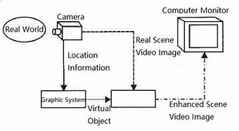
Commercial AR experiences were first introduced in entertainment and gaming businesses. Subsequently, AR applications have spanned commercial industries such as education, communications, medicines and entertainment. In education, content may be accessed by scanning or viewing an image with a mobile or by using markerless AR techniques.

Fig-1.3 How Augmented Reality Works
ADVANTAGES AND DISADVANTAGES OF AR
Advantages are
- Creates Unique Customer experiences.
- It eliminates cognitive overload.
- Heightens User Engagement.
- Compitive differentiation.
- Increase user knowledge and information.
- Ability to share your experience with other people in real time over long distances.
Disadvantages are
- It is very expensive to implemented and develop AR technology based projects and to maintain it.
- It is very costly to develop Augmented Reality (AR) enabled services.
- Lack of privacy is major drawback of Augmented Reality.
- Low performance level of AR devices is a major drawback which can be arise during testing phase.
FUTURE WORK
The need for skilled programmers and coders with master’s degrees in software development is expected to increase dramatically. According to market experts, the AR market will be worth 470bn to $75bn by 2023. Before AR technology reaches the pinnacle, it must become more than an afterthought on mobile devices.
SUMMARY
Simply, Augmented Reality (AR) is an enhanced version of the real physical world that is achieved through the use of digital visual elements, sounds, or other sensory stimuli delivered via technology. It is a growing trend among companies involved in mobile computing and business applications in particular.
REFERENCES
- https://en.wikipedia.org/wiki/Augmented_reality
- https://www.investopedia.com/terms/a/augmented-reality.asp
- https://www.merriam-webster.com/dictionary/augmented%20reality
- https://byjus.com/free-ias-prep/augmented-reality/
- https://www.interaction-design.org/literature/topics/augmented-reality

